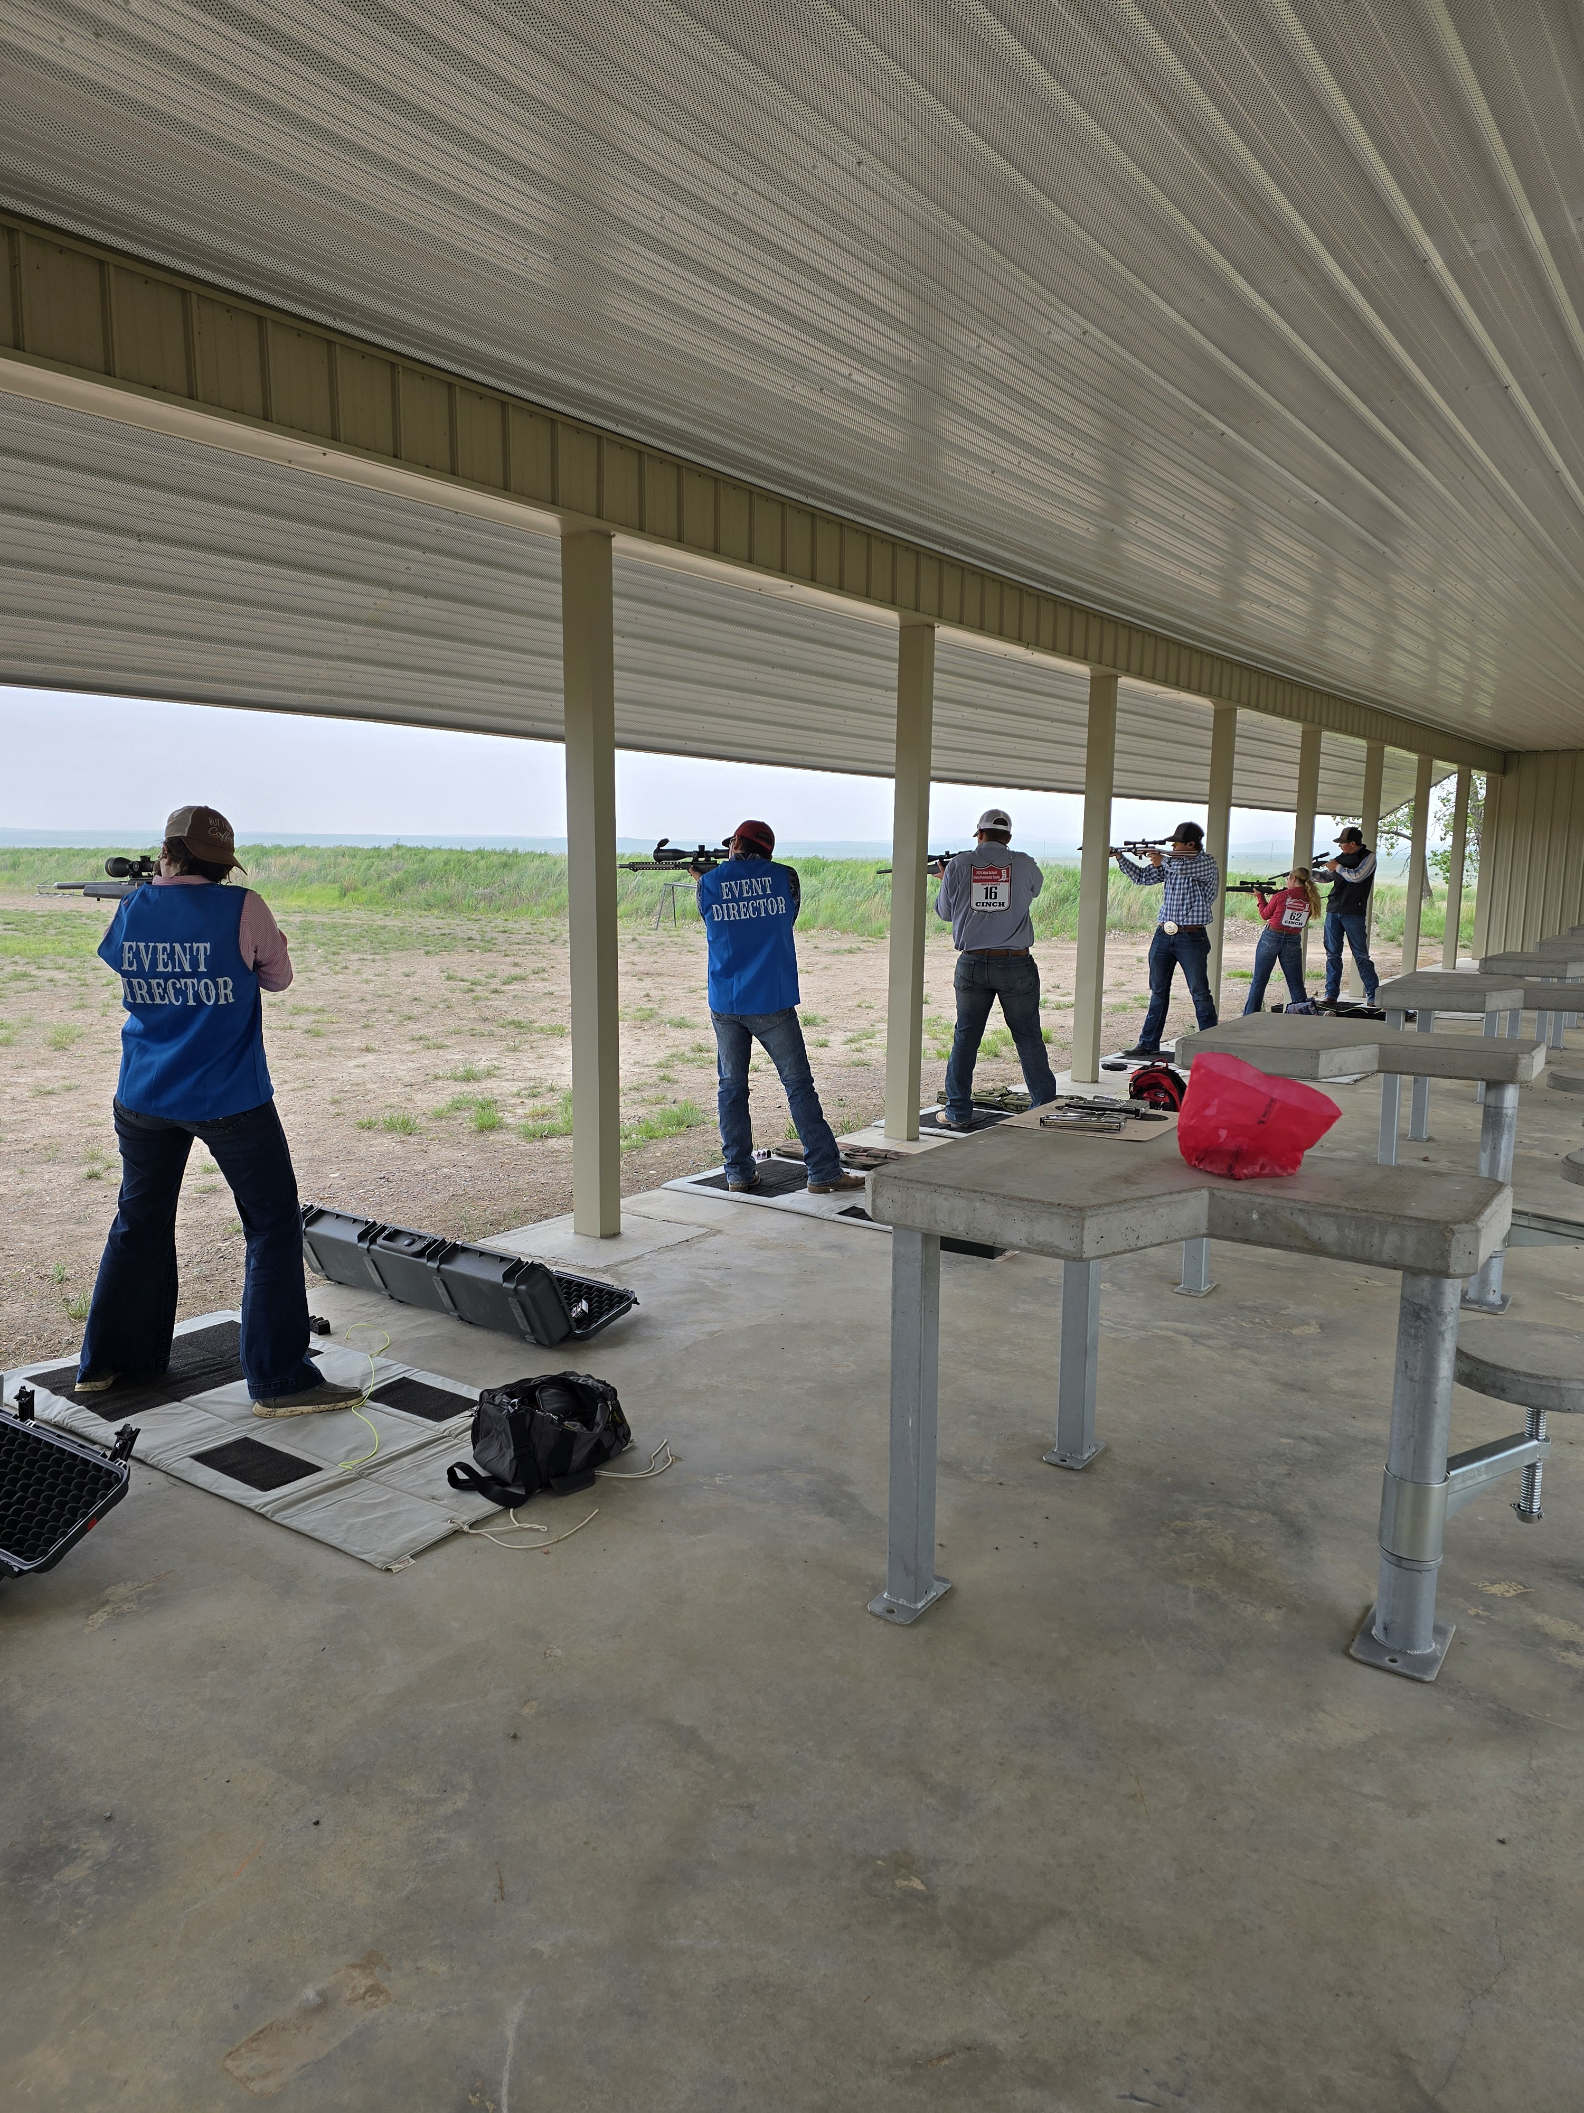  - NDHSRA  Shooting Qualifier @ Slope Area Rifle & Pistol Club for the dickinson Rodeo  To replace any tip text with your own, just tap it and start typing. To replace the photo or logo with your own, on the Insert tab of the ribbon, just select the option you need. To try out different looks for this flyer, on the Design tab, check out the Themes, Colors, and Fonts galleries.  
  August 28, 2026 @ 10:30 am MT
  ____
  Come joins us for our New qualifier at another beautiful range
  ____
  Bring plenty of ammo and don’t be late
  ____
  We will shoot Rifle first and then Trap
  Slope Area Rifle & Pistol Club
  1500 ND-22
  Manning, ND 58642
  Safety Meeting will start @ 10:15 MT

